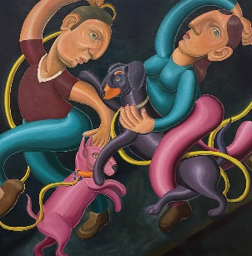 | ELINA OJAKANGAS  DISCO DOGS  Oil on linen  90 x 90cm  $3900 |  | ELINA OJAKANGAS  THE FAINTING MAN  Oil on linen  100 x 120cm  $3700
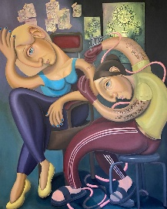 | ELINA OJAKANGAS  LAST NIGHT  Oil on linen  120 x 150cm  $4200 | 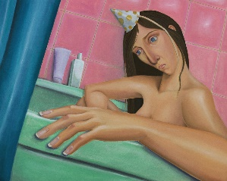 | ELINA OJAKANGAS  LIVE, LOVE, LAUGH  Oil on linen  100 x 80 cm  $3500

