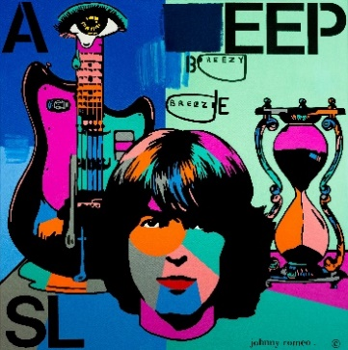  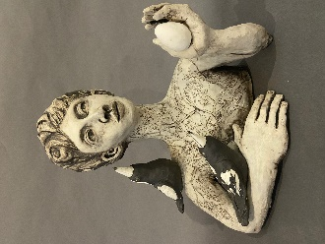 | JOHNNY ROMEO  BREEZY BREEZE  Acrylic and oil on canvas  101 x 101 cm  $5885 | 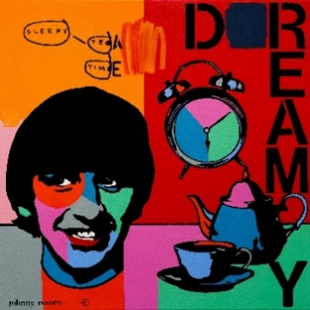 | JOHNNY ROMEO  SLEEPY TEA TIME  Acrylic and oil on canvas  101 x 101 cm  SOLD
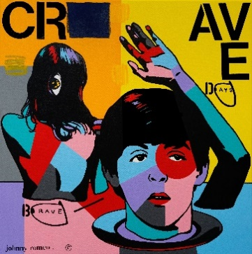 | 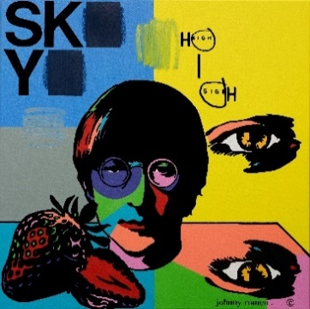  JOHNNY ROMEO  BRAVE DAYS  Acrylic and oil on canvas  101 x 101 cm  $5885 |  | JOHNNY ROMEO  HIGH SIGH  Acrylic and oil on canvas  101 x 101 cm  $5885
JOHNNY ROMEO - NOTHING IS REAL

ANGIE GOTO - EMANCIPATION
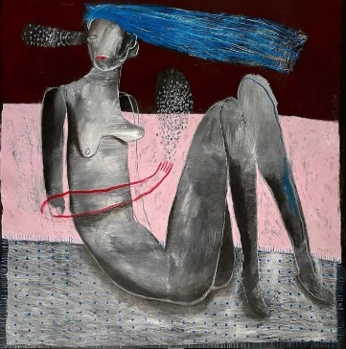 | ANGIE GOTO  IT’S A GIVEN  Mixed media on canvas  99 x 97 cm  $3200 | 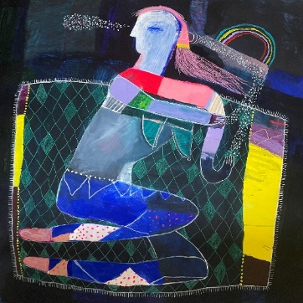 | ANGIE GOTO  MUSIC IN MY EYES  Mixed media on canvas  100 x 100 cm  $3200
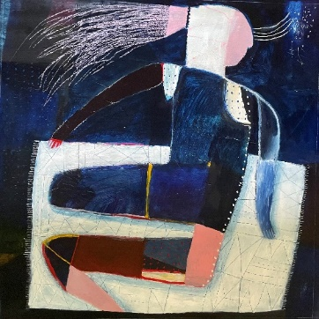 | ANGIE GOTO  SILENCE HAS A SOUND  Mixed media on canvas  82 x 83.5 cm  SOLD | 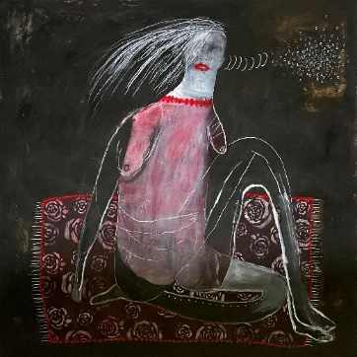 | ANGIE GOTO  MY EYE IS MY EAR  Mixed media on canvas  90 x 90 cm  $3000

GLENDON CORDELL - OTHER WORLDY PLACES
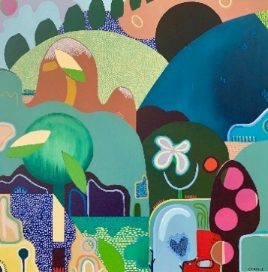 | GLENDON CORDELL  ECLECTIC DREAMING  Acrylic on canvas (Framed)  102 x 102 cm  SOLD | 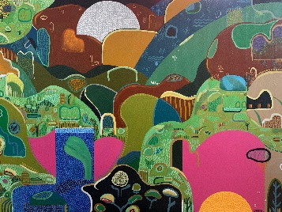 | GLENDON CORDELL  MEANDERING MOON  Acrylic on canvas (Framed)  91 x 122 cm  $3000
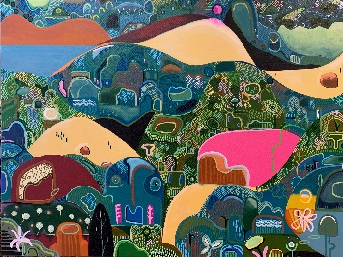 | GLENDON CORDELL  I WILL FIND YOU  Acrylic on canvas (Framed)  91 x 122 cm  $3000 | 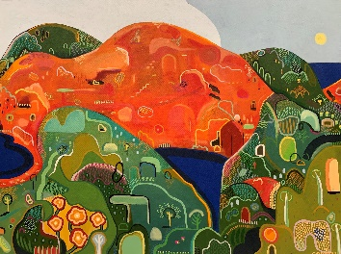 | GLENDON CORDELL  BLOOMING  Acrylic on canvas (Framed)  91 x 122 cm  $3000

MISS MORESBY - COLOUR THERAPY
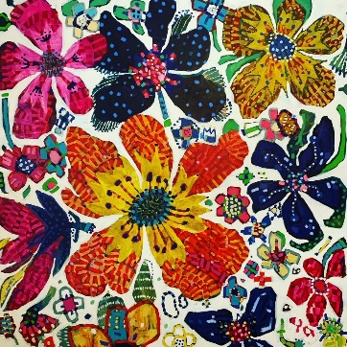 | MISS MORESBY  ANNUAL SHOW  Oil on canvas (Framed)  121 x 121 cm  $3900 | 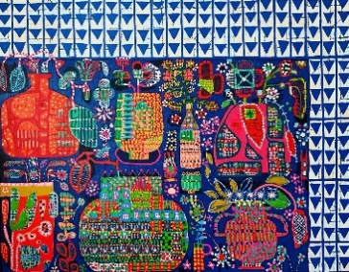 | MISS MORESBY  BLOOMS ON BLUE  Oil on canvas (Framed)  121 x 150 cm  SOLD
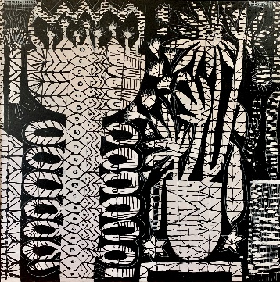 | MISS MORESBY  MONOKROMATIK  Acrylic on canvas (Framed)  121 x 121 cm  $3900 | 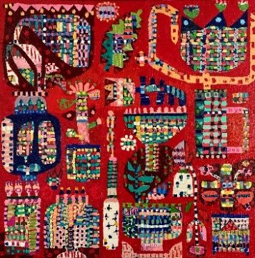 | MISS MORESBY  NEVER REDDER  Oil on canvas (Framed)  83 x 83 cm  SOLD

AMANDA SHELSHER - BIRD SONG
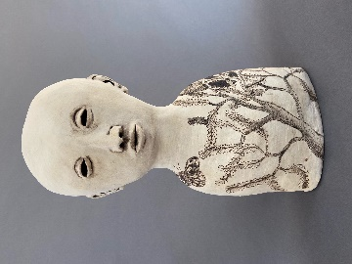 | AMANDA SHELSHER  BANKSIA  Hand built stoneware, slips, stains, glaze  39 h x 19 w x 9 d cm  $1500 | 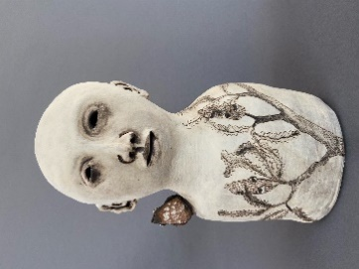 | AMANDA SHELSHER  BANKSIA SONG  Hand built stoneware, slips, stains, glaze  34 h x 18 w x 11 d cm  $1600
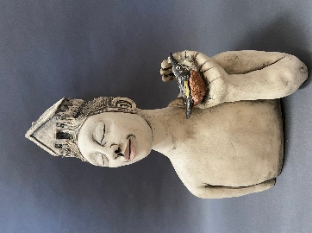 | AMANDA SHELSHER  SAFE  Hand built stoneware, slips, stains, glaze  48 h x 31w x 23 d cm  $2900 | 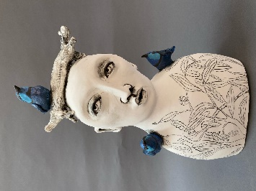 | AMANDA SHELSHER  SPLENDID FAIRY DAY  Hand built stoneware, slips, stains, glaze  46 h x 26 w x 13 d cm  $2200
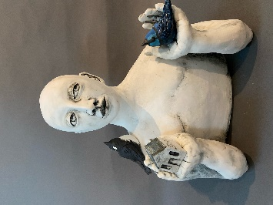 | AMANDA SHELSHER  MATTER OF URGENCY  Hand built stoneware, slips, stains, glaze  40 h x 35 w x 25 d cm  $3200 | 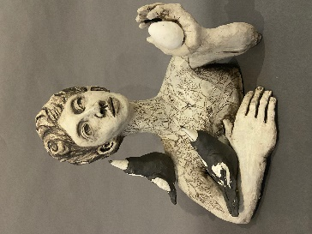 | AMANDA SHELSHER  MAGPIE  Hand built stoneware, slips, stains, glaze  40 cm w x 40 cm h x 21 d cm  $3200

ALISON MOONEY - 25 THINGS I’M CURIOUS ABOUT
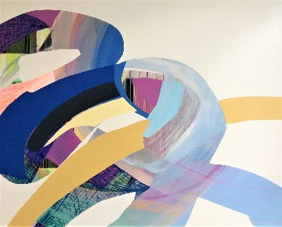 | ALISON MOONEY  FOLLOWING THE THREAD  Mixed media on canvas  121.5 x 152 cm  $5500 | 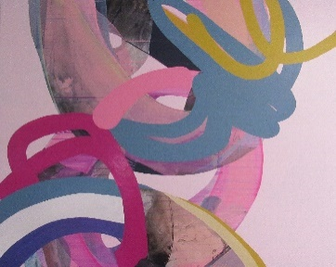 | ALISON MOONEY  TANGLED UNDER COVERS  Mixed media on canvas  122 x 152 cm  $5500
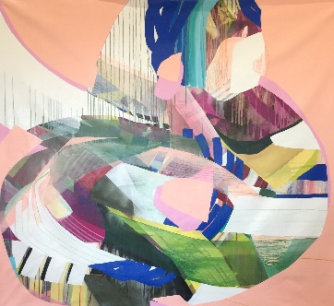 | ALISON MOONEY  DOPAMINE ON TAP  Mixed media on canvas  180 x 190 cm  $6500 | 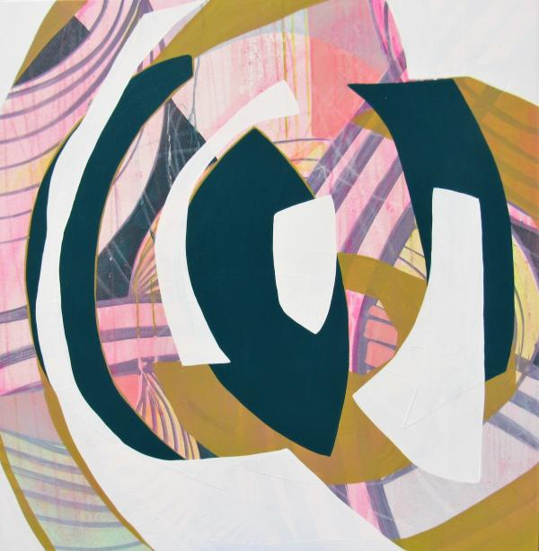 | ALISON MOONEY  PERCEPTION SHIFT  Mixed media on canvas  91.5 x 91.5 cm  $2900
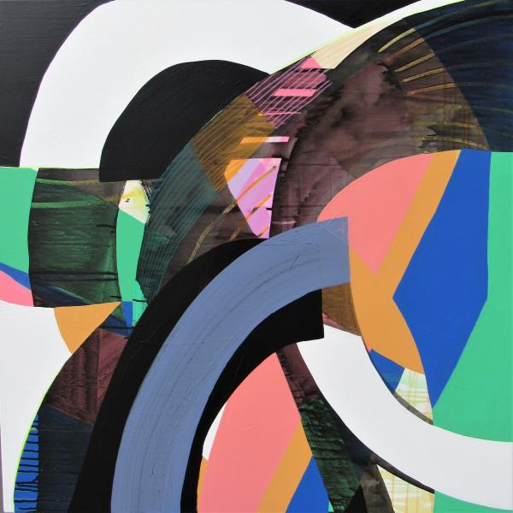 | ALISON MOONEY  LIMITED EDITION AIR MAX  Mixed media on canvas  91.5 x 91.5 cm  $2900 | 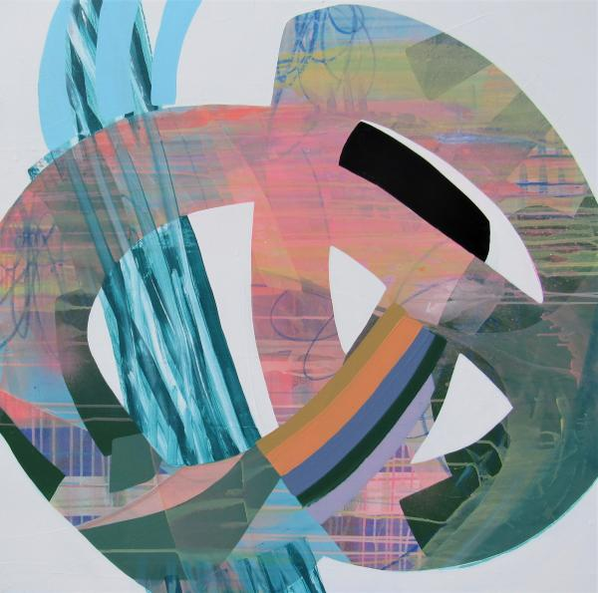 | ALISON MOONEY  BAYS OF COOLUM  Mixed media on canvas  91.5 x 91.5 cm  $2900

